ME222 - Design of Machine Elements

**DESIGN OF A STRING HOPPER MACHINE**

**GROUP ME1**

E/17/184 LAKSHAN P.A.C.

E/18/009 ABEYWEERA P.S.

E/18/014 AHAMAD I.L.A.

E/18/035 BANDARA L.R.L.P.

E/18/037 BANDARA N.M.I.W.

According to the finalized design for the string hopper machine from the previous “ME 220” course, here further developments to the above design are placed. The standard design procedure is followed for making machine elements (shafts, gears, etc.) in the string hopper machine. Considering the failures that might happen in each machine element, their dimensions have been decided. The procedure is as follows to obtain the optimum dimensions for the parts of the string hopper machine.

**OBJECTIVES**

1. Analyze the major stresses occur in the components of the string hopper machine and decide suitable dimensions to withstand these failures

2. Select suitable materials for each component

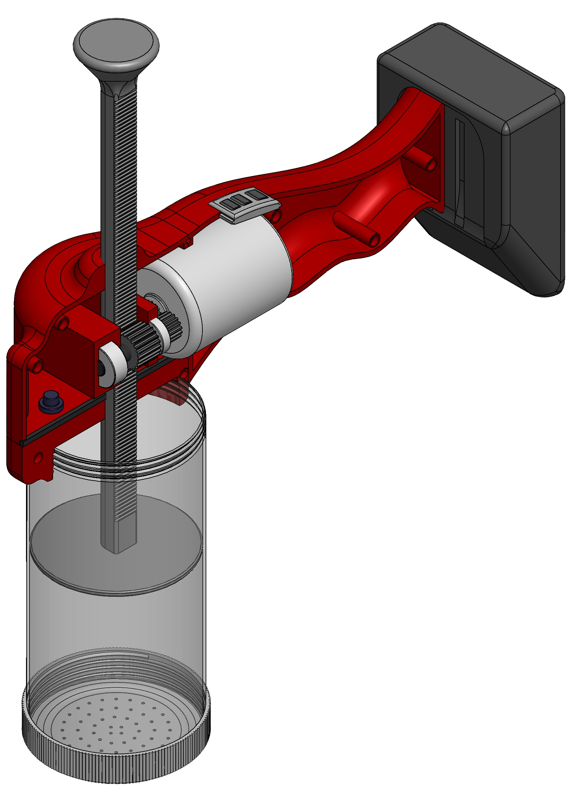

Moving rod

Battery

Bearing (A)

Switch panel

Plastic casing

Motor

Shaft supporting   
bars

Sensor

Bearing (C)

Shaft

Detachable cylinder

Extruding disc

Gear (B)

Extruding plate

Gear (D)

Bottom cylinder cap

Figure 01(a) : Components of the string hopper machine

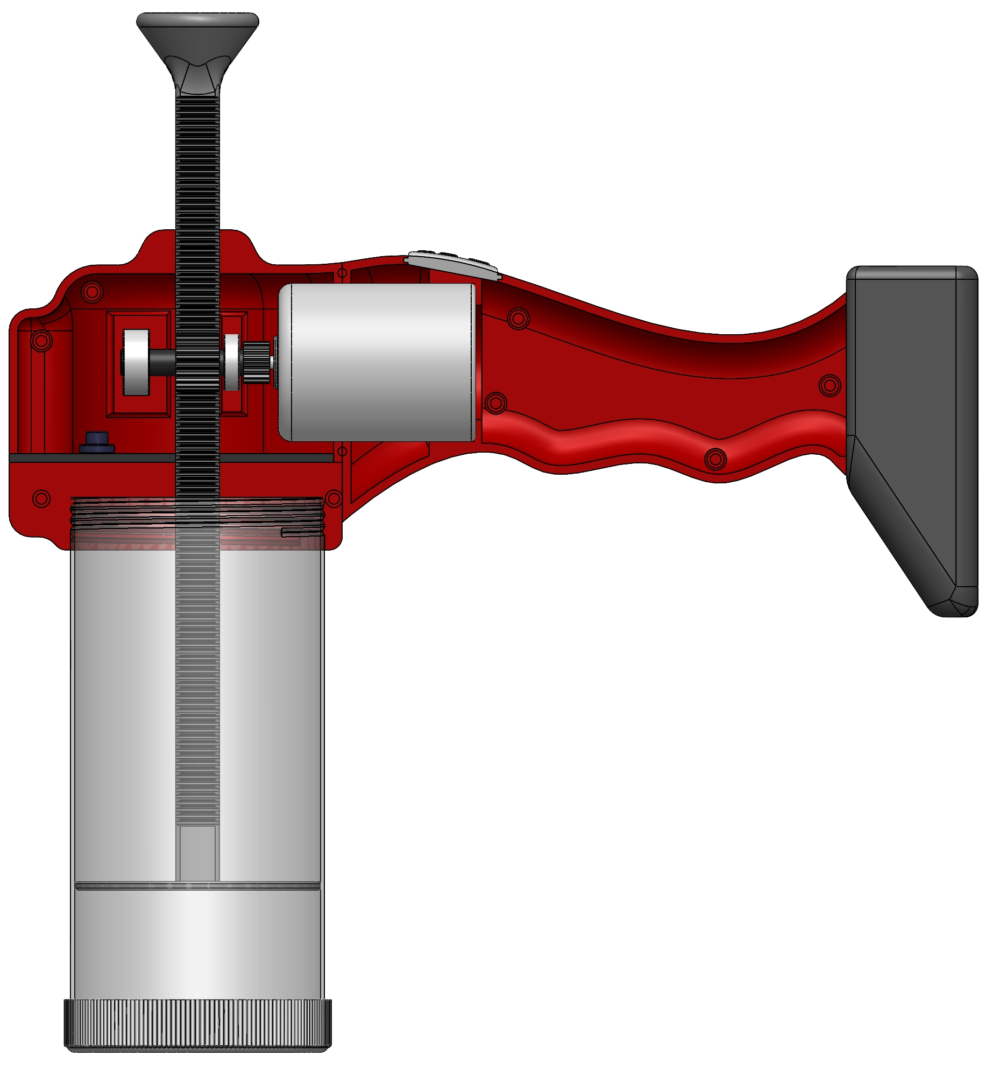

Cylinder inside diameter 60mm

45 mm

230 mm

200 mm

100 mm

Figure 01(b) : Main dimensions of the string hopper machine

**Assumptions**

* Moving rod is assumed as a column when analyzing under bending and compression
* The frictional torque of the bearing is negligible.
* Shaft is of a uniform cross section
* Axial forces of the shaft are negligible
* Flour mold is assumed to be constant density

**Design Data**

* Maximum vertical force required to push the mold (F) is 40N
* Inside diameter of the cylinder is 60mm
* Volume of a string hopper is assumed to be 24 cm3
* Maximum travel length of the moving rod is 100mm
* Vertical distance between bottom of the extruding disc and the shaft axis is assumed to be 150mm
* Extrusion time for a string hopper is 3s
* Number of holes in extruding disc is 55
* Diameter of an extruding hole is 1mm
* Diameter of the shaft is 6mm
* Pitch circle diameter of gear B is 11mm
* Pitch circle diameter of gear D is 7.8mm

**Table 01 : Failure Modes**

|  |  |
| --- | --- |
| **Component** | **Failure Modes** |
| Moving rod | Compressive failure  Buckling failure |
| Gears | Shearing of teeth |
| Shaft | Bending failure  Shear failure  Torsional failure |
| Extruding plate | Compressive failure  Shear failure  Crushing failure |
| Threads of cylinder | Shear failure  Bending failure |
| Extruding disc | Compressive failure  Bending failure  Crushing failure  Shear failure |
| Bottom cylinder cap | Tensile failure  Crushing failure |
| Detachable cylinder | Tensile failure |
| Shaft supporting bars | Bending failure  Shear failure |

**Table 02 : Materials Properties**

|  |  |  |  |  |  |  |  |  |
| --- | --- | --- | --- | --- | --- | --- | --- | --- |
| **Component** | | **Material** | **Tensile**  **Strength**  **/(MPa)** | **Compressive**  **Strength**  **/(MPa)** | **Shear**  **Strength**  **/(MPa)** | **Bearing**  **Strength**  **/(MPa)** | **F.O.S** | **Ref. No** |
| Moving rod | | SAE 304 stainless steel | 215 | 215 | 124.06 | 430 | 2 | 3 |
| Gears | B | SAE 304 stainless steel | 215 | 215 | 124.06 | 430 | 2 | 3 |
| D | SAE 304 stainless steel | 215 | 215 | 124.06 | 430 | 2 | 3 |
| M (motor) | SAE 304 stainless steel | 215 | 215 | 124.06 | 430 | 2 | 3 |
| Shaft | | Mild steel | 250 | 250 | 144.25 | 500 | 2 | 4 |
| Extruding plate | | SAE 304 stainless steel | 215 | 215 | 124.06 | 430 | 1.75 | 3 |
| Plastic casing | | Nylon | 80 | 80 |  |  | 1.5 | 5 |
| Battery pack casing | | Nylon | 80 | 80 |  |  | 1.5 | 5 |
| Cylinder | | SAE 304 stainless steel | 215 | 215 | 124.06 | 430 | 1.75 | 3 |
| Extruding disc | | SAE 304 stainless steel | 215 | 215 | 124.06 | 430 | 1.75 | 3 |
| Bottom cylinder cap | | SAE 304 stainless steel | 215 | 215 | 124.06 | 430 | 1.75 | 3 |

**Calculations**

|  |  |  |
| --- | --- | --- |
| **Reference** | **Calculations** | **Results** |
| Table 02  Figure 02  Ref. 1  Pg. 178  Figure 4-18  Equation 4-40  Ref. 6  APPENDIX B, A13  Figure 03 | 1. Design of the moving rod   Considering compressive failure  Assuming the rod as a column,  Diameter dr  150 mm  40 N  ­  Figure 02 : Moving Rod  Allowable compressive strength = 215/2  σAllow = 107.5 MPa  σAllow ≥ F/A  107.5 ≥ (40x4)/πdr2  dr ≥ 0.69 mm      Considering buckling failure  P383C5T3#y1Considering the rod as a both ends fixed column,  Figure 03 : Buckling failure of the rod  Moment of inertia of the cross  section of the rod (I) = πdr4/64  End condition constant (C) = 4  Allowable Young’s Modulus  (EAllow) = 200/2 MPa  = 100 MPa  Considering length of the column as the vertical distance between bottom of the extruding disc and the shaft axis,  L = 150 mm  By Euler Column Formula,  P = (Cπ2EI) / L2  P = (Cπ3E dr4) / 64L2  P ≤ (Cπ3 EAllow dr4) / 64L2    dr  ≥ [64PL2 / Cπ3 EAllow]0.25  ≥ [64x40x0.1502 / 4π3x100x106]0.25  ≥ 8.26 mm  Considering both conditions, Assumed that  dr = 12 mm | dr =  12 mm |
| Table 02  Figure 04 | 1. Design of the extruding plate   Diameter dr  Diameter dp  40 N  Thickness tp  Shearing area  ­­  Figure 04 : Extruding Plate  Considering compressive failure,  Allowable compressive strength = 215/1.75 MPa  σAllow = 122.86 MPa  σAllow ≥ F/A  122.86 ≥ (40x4)/πdp2  dp ≥ 0.64 mm  Since the assumed diameter is 60mm, it is acceptable.    Considering shear failure,  Allowable shear strength = 124.06/1.75 MPa  τAllow = 70.89 MPa  τAllow ≥ F/A  70.89 ≥ 40/πdrtp  tp ≥ 0.015 mm  Assumed that, tp = 2 mm | dp = 60mm  tp  = 2 mm |
| Table 02  Figure 05  Ref. 1  Pg. 407  Figure 06 | 1. Design of the detachable cylinder   Cylinder inside diameter  dcyl,in 60mm  Cylinder outside diameter dcyl,out  125 mm  Figure 05 : Detachable Cylinder  Considering compressive failure,  Allowable tensile strength = 215/1.75 MPa  σAllow = 122.86 MPa  σAllow ≥ F/A  122.86 ≥ (40x4)/π(dcyl,out2 - dcyl,in2)  122.86 ≥ (40x4)/π(dcyl,out2 – 602)  dcyl,out ≥ 60.01 mm  Assumed that, dcyl,out = 64 mm  Design of threads in cylinder  p  dmajor  dminor  t  Figure 06 : Threads of Cylinder  Table 03 : Assumed dimensions of threads   |  |  |  |  |  |  | | --- | --- | --- | --- | --- | --- | | Pitch (p) (mm) | Major diameter  ( dmajor)  (mm) | Pitch diameter  ( dpitch)  (mm) | Minor diameter  ( dminor)  (mm) | | Depth of thread  (t)  (mm) | | Nut | Bolt | | 2.5 | 64 | 62.5 | 62 | 61.8 | 1 |   Assuming number of threads contact with the bolt (nt) is 4,  Bearing stress of the thread (σbearing) = 2F/π dminor ntp  = (2x40) / (πx62x4x2.5)  = 0.041 MPa    Allowable bearing stress of the  thread (σbearing,allow) = 430/1.75 MPa  = 245.71 MPa  σbearing,allow ≥ σbearing  Bending stress of the thread (σbending) = 6F/π dminor ntp  = (6x40) / (πx62x4x2.5)  = 0.123 MPa    Allowable bending stress of the  thread (σbending,allow) = 215/1.75 MPa  = 122.86 MPa  σbending,allow ≥ σbending  The transverse shear stress at  the center of the root of the  thread (𝜏) = 3F/π dminor ntp  = (3x40) / (πx62x4x2.5)  = 0.061 MPa  Allowable shear stress of the  thread (𝜏allow) = 124.06/1.75 MPa  = 70.89 MPa  𝜏allow ≥ 𝜏  According to the above calculations, assumed dimensions of threads are acceptable.  Therefore, both top and bottom threads of the cylinder are made according to the dimensions in Table 03. | dcyl,out = 64 mm |
| Table 2  Figure 7  Ref. 7  Pg. 201 | 1. Design of the extruding disc   diameter 60mm  diameter  ddisc´  Hole diameter 1mm  thickness tdisc  Area under crushing  (b)  (a)  Figure 07 : bottom view (a) & top view (b) of the extruding disc  Considering compressive failure,  Allowable compressive strength = 215/1.75 MPa  σAllow = 122.86 MPa    Total area of extruding holes = 55πd2/4  (55 holes) = 55π x 12/4  = 43.2 mm2    Area under compression (A) = (π ddisc2 /4) - 43.2 mm2  = (π 602 /4) - 43.2 mm2  = 2784.23 mm2  Compressive stress (σ) = F/A  = (40/ 2784.23 ) MPa  = 0.014 MPa  σallow ≥ σ  Therefore, diameterof the disc is acceptable.    Considering bearing failure on the bottom,  Allowable bearing strength = 430/1.75 MPa  σBearing,allow = 245.71 MPa  Bearing stress (σBearing) = F/ [π (ddisc2 - ddisc´2)/4]  = 40 / [π (602 - ddisc´2)/4]  σBearing,allow ≥ σBearing  245.71 ≥ 40 / [π (602 - ddisc´2)/4]  ddisc´ ≤ 59.998 mm  Assumed that, ddisc´ = 45 mm  Considering shear failure,  Allowable shear strength = 124.06/1.75 MPa  τAllow = 70.89 MPa  τAllow ≥ F/A  70.89 ≥ 40/(π ddisc´ tdisc)  70.89 ≥ 40/(π x 45 x tdisc)  tdisc ≥ 0.004 mm  Assumed that, tdisc = 2 mm  Considering bending failure,  Assuming the extruding disc as an outer edge fixed flat circular plate with uniformly distributed load,  tdisc  Figure 08 : Bending of the extruding disc  w (unit load) = F/A  = 0.014 N/mm2  2a = ddisc´  = 45 mm  a = 22.5 mm  Maximum bending stress is given by,  σBending,max = 3wa2/4t2  = (3 x 0.014 x 22.52) / (4x22)  = 1.33 MPa  σBending,allow = 215/1.75 MPa  = 122.86 MPa  σBending,max ≤σBending,allow  According to the above calculations, assumed dimensions for the extruding disc are acceptable. | ddisc =  60 mm  ddisc´ = 45 mm  tdisc =  2 mm |
| Figure 09  Ref. 12 | 1. Design of the bottom cylinder cap   45mm  64mm  dcap,out  Thickness tcap    Figure 09 : Dimensions of the bottom cylinder cap  Considering tensile failure,    Allowable tensile strength = 215/1.75 MPa  σAllow = 122.86 MPa  σAllow ≥ F/A  122.86 ≥ (40x4)/π(dcap,out2 – 642)  dcap,out ≥ 64.0033 mm    Assumed that, dcap,out = 68 mm  Considering bending failure,  Assuming the bottom part of the cap as a circular flat plate with central hole, uniform load over ring, clamped at outer edge  P1296C17T3#y1  Figure 10 : Dimension of the bottom part of the cap      According to the dimensions of cap,  a = 64/2 mm  = 32 mm  b = 45/2  =22.5 mm    p = F/A  = 40 / π(322 – 22.52)  = 0.025 N/mm2  Maximum bending stress is given by,  σBending,max = k ( pa2/t2 )    Here kis a constant depend on (a/b)  For (a/b) = 1.25, k = 0.105  For (a/b) = 1.5, k = 0.259  In this case, (a/b) = 32/22.5 = 1.422  Assuming linear relationship between (a/b) and k,  For (a/b) = 1.422, k = $\left(\frac{0.259-0.105}{1.5-1.25}\right)\left(1.422-1.25\right)+0.105$   k = 0.211  Then,  σBending,max = k ( pa2/t2 )  = ( 0.211 x 0.025 x 322 ) /t2  = 5.4016/t2  σBending,allow = 215/1.75 MPa  = 122.86 MPa  To prevent failure,  σBending,max ≤σBending,allow  5.4016/t2 ≤ 122.86 MPa    t ≥ 0.21 mm  Assumed that, t = 2 mm | dcap,out = 68 mm  t =  2 mm |
| SKF Bearing Catalog  Pg. 260 | 1. Selection of the bearings   A single row deep groove ball bearings are selected.  P1481C20T3#y1  Figure 11 : Dimensions of the bearing  Bearings are selected considering the shaft diameter 6mm.  Table 04 : Properties of the bearing (A)   |  |  |  |  |  |  |  |  | | --- | --- | --- | --- | --- | --- | --- | --- | | Principal Dimensions | | | Load Rating | | Limiting  Speed  (rpm) | Mass  (kg) | Designation | | d  (mm) | D  (mm) | B  (mm) | Dyn.  (N) | Stat.  (N) | | 6 | 15 | 6 | 884 | 270 | 50 000 | 0.0039 | 619/6-2Z |   Table 05 : Properties of the bearing (C)   |  |  |  |  |  |  |  |  | | --- | --- | --- | --- | --- | --- | --- | --- | | Principal Dimensions | | | Load Rating | | Limiting  Speed  (rpm) | Mass  (kg) | Designation | | d  (mm) | D  (mm) | B  (mm) | Dyn.  (N) | Stat.  (N) | | 6 | 13 | 3.5 | 715 | 224 | 67 000 | 0.002 | 618/6 | |  |
| Figure 12  Figure 13  Ref. 10  Ref. 11  Figure 14(a)  Figure 14(b)  Table 02 | 1. Design of the shaft   0.5  6  6  10  1  3.5  1  6  Ø 15  Ø 6  Pitch Ø 11  Ø 12.6  Pitch  Ø 7.8  A  B  C  D  Figure 12 : Dimensions of the shaft components in mm  3.25  14.25  7.75  5.75  3  40N  A  B  C  D  RA  RC  FD  TB  TD  Figure 13 : FBD of the shaft  Torque (TB) = vertical force x (pitch circle diameter of gear B/2)  = 40N x (11/2)mm  = 220 Nmm  Considering torque balance,  TB = TD = 220 Nmm  TD = 220 Nmm  FD x (pitch circle diameter of gear D/2)= 220 Nmm  FD x (7.8/2) = 220 Nmm  FD = 56.41 N  Considering moment about A,  (40 x 14.25) – (Rc x 22) – (FD x 27.75) = 0  (40 x 14.25) – (Rc x 22) – (56.41 x 27.75) = 0    Rc = -45.24 N  Considering vertical equilibrium,  RA + Rc + FD = 40N  RA - 45.24 + 56.41 = 40N    RA = 28.83 N  x (mm)  3.25  17.5  25.25  31  34  0  -324.35  -410.88  Bending moment (N-mm)    Figure 14(a) : Bending moment diagram of the shaft  Torque (N-mm)  220  0  3.25  17.5  25.25  31  34  x (mm)    Figure 14(b) : Torque diagram of the shaft  Maximum bending stress on the shaft is given by,    σbending,max = 32Mmax / πd3  = (32x410.88) / (πx63)  = 19.38 MPa  σbending,allow = 250 / 2  = 125 MPa  σbending,max < σbending,allow  Maximum shear stress on the shaft is given by,  τmax = 16Tmax / πd3  = (16x220) / (πx63)  = 5.19 MPa  τallow = 144.25 / 2  = 72.125 MPa    τmax < τallow  Therefore, assumed diameter of the shaft is acceptable when considering bending and shear failures.  Considering The Distortion-Energy Theory (DET),  Min. diameter of the shaft to prevent failure is given by,  dmin =  - Yield stress $n_{s}$ - factor of safety  dmin =  dmin = 3.33 mm  Considering The Maximum Shear-Stress Theory (MSST)  Min. diameter of the shaft to prevent failure is given by,  dmin =  - Yield stress $n_{s}$ - factor of safety  dmin =  dmin = 3.36 mm  According to both DET & MSST,  Shaft diameter > 3.36 mm  Therefore, assumed diameter of the shaft which is 6 mm is acceptable. | FD =  56.41 N  Rc =  -45.24 N  RA =  28.83 N  Mmax =  410.88 Nmm  Tmax =  220 Nmm  dmin = 3.33 mm  dmin = 3.36 mm  dshaft =  6 mm |
| Table 04  Table 05  Step 6  Step 7 | 1. Checking the bearings for load ratings considering   reaction forces RA & RC   * According to the Table 04 and Table 05, Maximum static load ratings for the bearing (A) and (C) are 270 N and 224 N respectively. * From step 6, reaction forces at A and C are obtained as RA = 28.83 N & Rc = -45.24 N. * Since the load ratings of the bearings are greater than the reaction forces, selected bearings are acceptable. |  |
| Figure 12  Figure 13  Ref. 2  Chp. 28 | 1. Design of gear wheels   Calculations for gear speeds  Pulp volume required for a string hopper = 24cm3  Time taken to extrude a string hopper = 3s  Extruding rate = 24/3 cm3s-1  = 8 cm3s-1  Area of the extruding plate = 62 π /4 cm2  = 28.27 cm2  Velocity of the moving rod (Vrod) = (8/28.27) cms-1  = 2.83 mms-1  At the contact point of gear B and moving rod,  Velocity of the gear B (VB) = Velocity of the   moving rod  = 2.83 mms-1  Angular speed of gear B (ωB) = VB / rB  = 2.83/5.5 rads-1  = 0.514 rads-1    RPM value of gear B = 4.9  Since B and D gears are connected to the same shaft,  Angular speed of gear D (ωD) = ωB  = 0.514 rads-1    RPM value of gear D = 4.9  Assuming gear wheel attached to the motor is same as gear D,  Angular speed of motor gear (ωM) = ωD  = 0.514 rads-1    RPM value of motor gear = 4.9  Design of gear B (Pinion gear)  The proposed gear system is a 14 $1/2°$ composite involute system.  Power transmitted (P) = FVB  = 40 x 2.83 x 10-3  = 0.1132 W  Pitch line velocity (v) = 2.83 x 10-3    Service factor (Cs) is decided based on following conditions.   * Type of load – Light shock * Intermittent or 3 hours per day.   Cs = 1.00 / 0.65  = 1.54  Permissible tangential tooth load (WT) = (P/v) Cs  = (0.1132/2.83 x 10-3)x1.54  = 61.82 N    Let the module (m) = 1  Dp/Tp = 1  Tp = 11/1  Number of teeth (Tp) = 11  Lewis form factor of gear B (y) = 0.124 – (0.684/ Tp)  = 0.124 – (0.684/ 11)  = 0.062    Applying the Lewis equation,  Wt = σwbπmy  = σoCvbπmy  = 107.5x106x1x10x  10-3xπx1x0.062  = 209.4 kN    Allowable static stress of gear B = 215/2  = 107.5 MPa  For ordinary cut gears operating at velocities up to 12.5 m/s,  Cv = 3/(3+v)  = 3/(3+2.83 x 10-3)  = 1  Width of gear face (b) = 10 mm  Let tangential tooth load (Wt) = 209.4 kN  Deformation factor for the gear B (C) = 880 N/mm  Total dynamic  load (WD) =    =  = 209.4 kN  Static tooth  load (WS) = σebπmy  = 252 x 106 x 10x10-3 x π x 1x 0.062  = 490.8 kN  Since WS > WD , selected values are acceptable.  Wear load (WW) = DpσQK  = 11 x 10-3 x 10 x 10-3 x 2 x 0.46 x 106  = 101.2 N  Therefore, selected value for module is acceptable.  m = 1  Ratio factor for external gears (Q) = 2VR/(VR+1)  = 2x1/(1+1)  = 2  Here, VR denotes velocity ratio.  Material combination  factor (k) = $\frac{σ_{es}^{2}\sin{φ}}{1.4}\left[\frac{1}{E_{P}}+\frac{1}{E_{G}}\right]$   = $\frac{{\left(350×{10}^{6}\right)}^{2}\sin{14.5°}}{1.4}\left[\frac{1}{190×{10}^{9}}+\frac{1}{190×{10}^{9}}\right]×2$   = 0.46 MPa  According to the selected module (m=1), key dimensions for the gear B is as follows.  Table 06 : Key dimensions for the gear B   |  |  |  | | --- | --- | --- | | Particulars | Proportions for14 $1/2°$ composite system | Values  /(mm) | | Addendum | 1m | 1 | | Dedendum | 1.25m | 1.25 | | Working depth | 2m | 2 | | Minimum total depth | 2.25m | 2.25 | | Tooth thickness | 1.5708m | 1.5708 | | Minimum clearance | 0.25m | 0.25 | | Fillet radius at root | 0.4m | 0.4 |     Figure 15 : Terms used in gears  Design of gear D and M  Pitch circle diameters of gear D and M are the same.  Assuming same module as gear B, key dimensions for the gear D and M are as follows.  Table 06 : Key dimensions for the gear D and M   |  |  |  | | --- | --- | --- | | Particulars | Proportions for14 $1/2°$ composite system | Values  /(mm) | | Addendum | 1m | 0.44 | | Dedendum | 1.25m | 0.56 | | Working depth | 2m | 0.89 | | Minimum total depth | 2.25m | 1 | | Tooth thickness | 1.5708m | 0.698 | | Minimum clearance | 0.25m | 0.11 | | Fillet radius at root | 0.4m | 0.178 |   module (m) = 1  Dp/Tp = 1  Tp = 7.8/1  Number of teeth (Tp) = 8 | Vrod =  2.83 mms-1  VB =  2.83 mms-1  ωB =  0.514 rads-1  RPM (B) =  4.9  ωD =  0.514 rads-1  RPM (B) =  4.9  ωM =  0.514 rads-1  RPM (M) =  4.9 |
| Step 7  Step 9  Ref. 8  Ref. 9 | 1. Selection of the motor   Maximum torque required by the motor = 220 Nmm  Required motor speed = 4.9 RPM  A NBLEISON LS-25GA370 series motor is selected.  According to their [catalog](https://www.nbleisonmotor.com/LS-25GA370-Dc-Gear-Motor-pd6387204.html), motor’s voltage, speed, torque & shaft dimensions can be customized.  Table 04(a) : Properties of the available motor   |  |  | | --- | --- | | **Model** | LS-25GA370-274 | | **Rated voltage** | DC 12 V | | **Speed at max. efficiency** | 16.6 RPM | | **Load current** | 137 mA | | **No-load starting current** | 450 mA | | **Power at max. efficiency** | 0.55 W | | **Max. torque** | 436.1 Nmm | | **Shaft diameter** | 4 mm |   Since the available motor speed (16.6 RPM) is higher than the required motor speed (4.9 RPM), customized motor with the speed of 4.9 RPM is required.  Table 04(a) : Properties of the customized motor   |  |  | | --- | --- | | **Model** | LS-25GA370-274 | | **Rated voltage** | DC 12 V | | **Speed at max. efficiency** | 4.9 RPM | | **Load current** | 137 mA | | **No-load starting current** | 450 mA | | **Power at max. efficiency** | 0.55 W | | **Max. torque** | 436.1 Nmm | | **Shaft diameter** | 4 mm |   **P2358C32T3#y1**  Figure 16(a) : LS-25GA370-274 motor  **P2375C32T3#y1**  *L is chosen as 19mm under the gear box options from the catalog.  Figure 16(b) : Dimensions of the motor |  |
| Ref. 13  Ref. 13  Figure 17(a)  Ref. 14  Ref. 13  Ref. 13  Ref. 14 | 1. Design of shaft support bars   Support bars are assumed as both ends fixed bars with internal hinges.  Considering support bar that contains bearing A,  39.25  21.25  22  Width 12  28.83 N  Bearing A  Figure 17(a) : Dimensions of cross section of the support bar with bearing A (in mm)      Figure 17(b) : Free body diagram of the beam  Comparing Figure 14(a) & Figure 14(b),  P = 28.83 N  a = 39.25 mm  b = 21.25 mm  With the condition that the vertical deflection of the free ends of the two separated cantilever beams is identical,  Force R is given by,  R = Pa3 / ( a3 + b3 )  = ( 28.83 x 39.253 ) / ( 39.253 + 21.253)  = 24.88 N  Then,  P-R = 28.83 - 24.88 N  = 3.95 N  28.83 N  A  C  B  RA  RB  MB  MA  3.95  24.88  528.7  155.04  39.25 mm  21.25 mm  V(N)  M (Nmm)  Figure 18 : SFD & BMD of support bar  Assuming rectangular cross section,  22 mm  12 mm  NA  c  Figure 19 : Cross section of the support bar  Moment of inertia (I) = (22 x 123) / 12  = 2200 mm4    Area of the cross section (A) = 22 x 12 mm2  = 264 mm2  Maximum bending stress on the beam is given by,    σbending,max = ( Mmax/I ) x c  = (528.7 / 2200) x 11  = 2.64 MPa    σbending,allow = 80/1.5 MPa  = 53.33 MPa  σbending,max < σbending,allow  Maximum shear stress on the beam is given by,  τmax = 3Vmax / 2A  = (3 x 24.88) / (2 x 264)  = 0.14 MPa    Assuming shear strength of nylon is half of tensile strength,    τallow = 26.67 / 1.5  = 17.78 MPa    τmax < τallow  Therefore, dimensions of the support bar are acceptable.  Considering support bar that contains bearing C,  34.86  16.86  20  Width 4.5  45.24 N  Bearing C  Figure 20(a) : Dimensions of cross section of the support bar with bearing C (in mm)      Figure 20(b) : Free body diagram of the beam  Comparing Figure 14(a) & Figure 14(b),  P = 45.24N  a = 34.86 mm  b = 16.86mm  With the condition that the vertical deflection of the free ends of the two separated cantilever beams is identical,  Force R is given by,  R = Pa3 / ( a3 + b3 )  = ( 45.24 x 34.863) / ( 34.863 + 16.863)  = 40.64 N  Then,  P-R = 45.24 – 40.64 N  = 4.6 N  45.24 N  A  C  B  RA  RB  MB  MA  4.6  40.64  685.2  160.36  34.86 mm  16.86 mm  V(N)  M (Nmm)  Figure 21 : SFD & BMD of support bar  Assuming rectangular cross section,  20 mm  4.5 mm  NA  c  Figure 22 : Cross section of the support bar  Moment of inertia (I) = (20 x 4.53) / 12  = 151.88mm4    Area of the cross section (A) = 15 x 4.5 mm2  = 90 mm2  Maximum bending stress on the beam is given by,    σbending,max = ( Mmax/I ) x c  = (685.2 / 151.88) x 10  = 45.1 MPa    σbending,allow = 80/1.5 MPa  = 53.33 MPa  σbending,max < σbending,allow  Maximum shear stress on the beam is given by,  τmax = 3Vmax / 2A  = (3 x 40.64) / (2 x 90)  = 0.68 MPa    Assuming shear strength of nylon is half of tensile strength,    τallow = 26.67 / 1.5  = 17.78 MPa    τmax < τallow  Therefore, dimensions of the support bar are acceptable. | Vmax =  24.88 N  Mmax =  528.7 Nmm  Vmax =  40.64 N  Mmax =  685.2 Nmm |
| Ref. 15  Ref. 16 | 1. Design of the battery pack   Re chargeable Li-ion 18650 batteries are use.  Required voltage for the motor = 12V  Voltage of a 18650 battery = 3.7 V  Number of batteries need = 12/3.7  = 3.24  Therefore, four 18650 batteries are connected in series to make the battery pack.  TP4056 battery charging module is used to charge and control the battery pack.    Figure 23 : Li-ion 18650 battery  Figure 24 : TP4056 battery charging module  40  60  80  20  50  Figure 25 : Dimensions of the battery pack casing |  |
|  | 1. Selection of screw for the casing   M2.5-0.45 x 12 mm Phillips Drive Pan Head Machine Screws Metric Zinc Plated in Steel are selected.  12 mm  Thread pitch 0.45 mm  Figure 26 : Dimensions of the screw | M2.5-0.45 x 12 |

**Design Summary**

|  |  |  |  |
| --- | --- | --- | --- |
| **Component** | **Dimension** | | **Values** |
| Moving rod | Length (L) | | 150 mm |
| Diameter (dr) | | 10 mm |
| Teeth | Addendum | 1 mm |
| Dedendum | 1.25 mm |
| Working depth | 2 mm |
| Minimum total depth | 2.25 mm |
| Tooth thickness | 1.5708 mm |
| Minimum clearance | 0.25 mm |
| Fillet radius at root | 0.4 mm |
| Gears | B | Pitch circle diameter | 11 mm |
| Module | 1 |
| Addendum | 1 mm |
| Dedendum | 1.25 mm |
| Working depth | 2 mm |
| Minimum total depth | 2.25 mm |
| Tooth thickness | 1.5708 mm |
| Minimum clearance | 0.25 mm |
| Fillet radius at root | 0.4 mm |
| Number of teeth | 11 |
| Face width | 10 mm |
| D/M | Pitch circle diameter | 7.8 mm |
| Module | 1 |
| Addendum | 0.4 mm |
| Dedendum | 0.56 mm |
| Working depth | 0.89 mm |
| Minimum total depth | 1 mm |
| Tooth thickness | 0.698 mm |
| Minimum clearance | 0.11 mm |
| Fillet radius at root | 0.178 mm |
| Number of teeth | 8 |
| Face width | 6 mm |
| Shaft | Length | | 34 mm |
| Diameter | | 6 mm |
| Extruding plate | Thickness (tp) | | 2 mm |
| Diameter (dp) | | 60 mm |
| Threads of cylinder | Pitch (p) | | 2.5 mm |
| Major diameter (dmajor) | | 64 mm |
| Pitch diameter (dpitch) | | 62.5 mm |
| Minor diameter (dminor) | | 62 mm |
| Depth of thread (t) | | 1 mm |
| Extruding disc | Diameter (ddisc) | | 60 mm |
| Diameter (ddisc´) | | 45 mm |
| Thickness (tdisc) | | 2 mm |
| Bottom cylinder cap | Outer diameter (dcap,out) | | 68 mm |
| Inner diameter (dcap,in) | | 64 mm |
| Bottom thickness (tcap) | | 2 mm |
| Hole diameter | | 45 mm |
| Detachable cylinder | Outer diameter (dcyl,out) | | 64 mm |
| Inner diameter (dcyl,in) | | 60 mm |
| Shaft supporting bars | A | Length | 60.5 mm |
| Height | 22 mm |
| Width | 12 mm |
| Bearing location (from left) | 39.25 mm |
| C | Length | 51.72 mm |
| Height | 20 mm |
| Width | 4.5 mm |
| Bearing location (from left) | 34.86 mm |
| Bearings | A | Shaft diameter (d) | 6 mm |
| Outer diameter (D) | 15 mm |
| Width (B) | 6 mm |
| C | Shaft diameter (d) | 6 mm |
| Outer diameter (D) | 13 mm |
| Width (B) | 3.25 mm |
| Screws of casing | Diameter | | 2.5 mm |
| Pitch | | 0.45 mm |
| Length | | 12 mm |

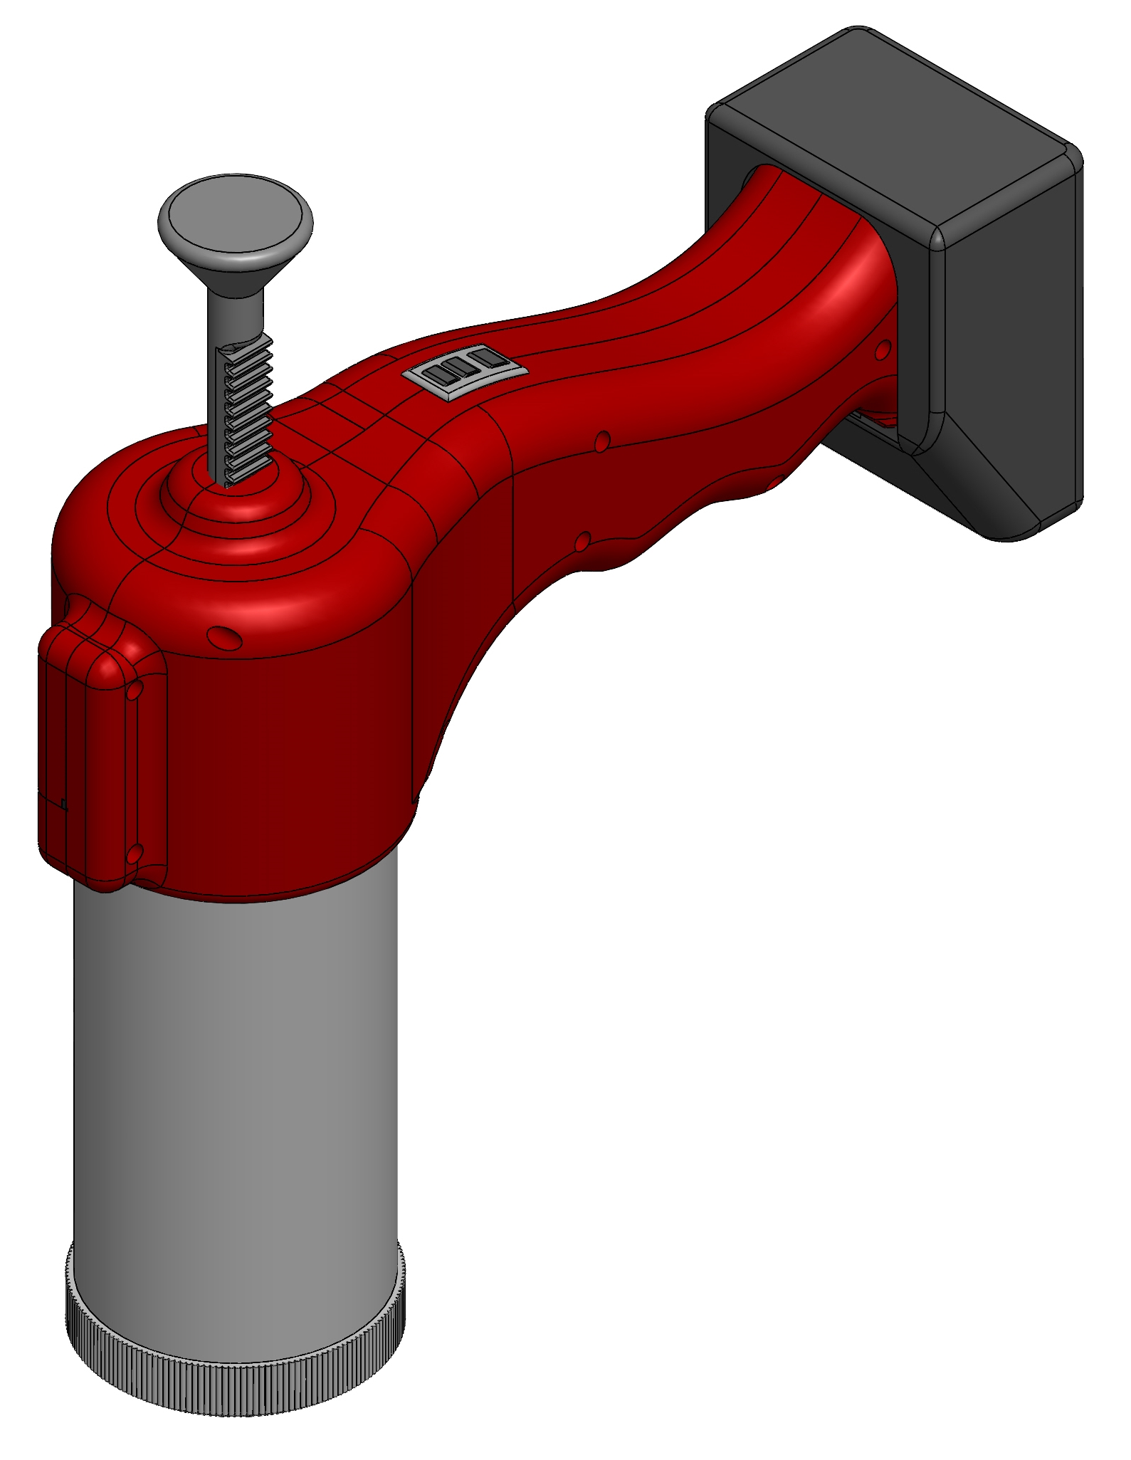

Figure 26 : Isometric view of the final product

**Reference**

1. Joseph Edward Shigley & Charles R. Mischke, “Mechanical Engineering Design”, 9th Edition, McGraw Hill Publication, 2011.
2. Kurumi and Gupta, “A Text Book of Machine Design”, Edition, 11, Illustrated, S. Chand publications Limited, 1996.
3. http://www.matweb.com/search/DataSheet.aspx?MatGUID=abc4415b0f8b490387e3c922237098da&ckck=1
4. https://material-properties.org/mild-steel-density-strength-hardness-melting-point/
5. http://polymerdatabase.com/Commercial%20Polymers/Polyamide.html
6. Beer Johnston Mechanics of Materials 6th Edition
7. The complete part design handbook by E. Alfredo Campo
8. https://www.nbleisonmotor.com/LS-25GA370-Dc-Gear-Motor-pd6387204.html
9. https://5nrorwxhiiqoiij.leadongcdn.com/LS-25GA370-aidlpBqmKinSRrpjilkloi.pdf
10. https://skyciv.com/free-beam-calculator/
11. Presentation slides on Design of Shafts
12. https://roymech.org/Useful_Tables/Mechanics/Plates.html#:~:text=Circular%20Flat%20Plate%20with%20central%20hole%20%2C%20uniform%20load%20over%20ring%2C%20clamped%20at%20outer%20edge
13. https://nptel.ac.in/content/storage2/courses/105101085/downloads/lec-29.pdf
14. https://mechanicalc.com/reference/beam-analysis
15. https://naccon.en.made-in-china.com/product/VNlJEpUHhskS/China-PCB-Protected-Rechargeable-Lithium-Battery-Point-Top-3-7V-2000mAh-Icr-18650-Battery.html
16. https://www.indiamart.com/proddetail/tp4056-battery-charging-module-19023528748.html